CAAP Quarterly Report
Date of Report: 1/15/2025

Prepared for: U.S. DOT Pipeline and Hazardous Materials Safety Administration

Contract Number: 693JK32050008CAAP

Project Title: Effectiveness Assessment of Pipeline Cathodic Protection System Using Remote Sensing, Advanced Modeling, and Data Analytics

Prepared by: Xingsen Yang (PhD student), Jay Shah (Postdoc), Qixin Zhou (Co-PI), Hao Wang (PI)

Contact Information: Hao Wang, hwang.cee@rutgers.edu, 848-445-2874

For quarterly period ending: 12/31/2024

Business and Activity Section

Contract Activity

The subaward to University of Akron has been issued.

Status Update of Past Quarter Activities

One PhD student (Xingsen Yang) joined the team and worked on this project with the postdoc (Jay Shah) at Rutgers University. Two undergraduate students (Ashley Chow and Cecilia Segretario) worked on this project at University of Akron.

The project team worked on the following tasks:
Task 2 Laboratory Tests of CP Performance under Various Factors
Task 3 Modelling and Simulation of CP Performance
Task 4 Remote Inspection of Soil Properties and Pipe Corrosion

Cost Share Activity

Cost share is provided by Rutgers University and University of Akron during this quarterly period as budgeted in the proposal.

Technical Approach

Task 1 Literature Review, Information Collection, and Refinement of Work Plan (completed)

Task 2 Laboratory Tests of CP Performance under Various Factors

The undergraduate students studied 1) soil properties and how to characterize them, 2) use of testing coupons and how to monitor corrosion behavior, and 3) CP levels and how to apply CP to the testing coupons.
An experimental plan considering testing parameters, metal coupons, soil samples, and testing procedures was developed. The experimental setups will apply CP coupled with electrochemical measurements. The investigating parameters include CP levels, moisture content, soil pH, soil type, coupon location in the soil, and total experimental time with CP. The testing/monitoring parameters include soil resistance, moisture content, pH, true CP potential feedback, and corrosion rate. The corrosion rate can be measured by electrochemical measurement and weight loss measurement. The metal for investigation is X70. The metal will be fabricated into electrodes for electrochemical measurements.
The students are identifying and purchasing the required experimental materials and devices for the testing, including metal coupons, soil samples, soil sensors (moisture content and pH), proctor compactor, soil meters, chemicals, etc.

Task 3 Modelling and Simulation of CP Performance

The spatial distribution of soil moisture significantly affects both the electrical conductivity and the diffusion coefficient, which are critical parameters influencing the performance of the cathodic protection (CP) system.
Richards' equation provides a robust framework for modeling water flow in variably saturated porous media, where hydraulic properties dynamically change as fluids fill some pores while draining others. Since its introduction, numerous adaptations of Richards' equation have been developed to simplify and enhance the modeling of flow in these complex systems. Its general formulation accommodates time-dependent changes in both saturated and unsaturated conditions, making it a versatile tool for simulating transient flow processes in diverse environmental and engineering applications
Richards' equation is employed to model water flow in variably saturated porous media, capturing the dynamic changes in hydraulic properties under both saturated and unsaturated conditions. In this study, Richards' equation is applied to investigate the moisture distribution across different soil types, enabling the analysis of their hydraulic properties under varying environmental conditions. The equation is presented as Equation 1 (Bear, 2013; Bear, 2012):
$ρ\left(\frac{C_{m}}{ρg}+SeS\right)\frac{∂p}{∂t}+∇∙ρ\left(-\frac{κ_{s}}{μ}k_{r}\left(∇p+ρg∇D\right)\right)=Q_{m}$ (1)
Where, the pressure, p, is the dependent variable. In this equation, Cm represents the specific moisture capacity, Se denotes the effective saturation, S is the storage coefficient, κ_{s} is the hydraulic permeability, μ is the fluid dynamic viscosity, k_{r} is the relative permeability, ρ is the fluid density, g is acceleration of gravity, D is the elevation, and Q_{m} is the fluid source (positive) or sink (negative).
Richards' equation depends on accurately defining soil hydraulic properties, including the relationships between water content, matric potential, and hydraulic conductivity. These nonlinear relationships vary with soil type and moisture conditions. The van Genuchten model (1980) is commonly used to describe these properties, providing an effective and flexible method for parameterizing soil hydraulic behavior. The van Genuchten model defines saturation at atmospheric pressure (Hp = 0) and provides constitutive relationships for soil water retention and hydraulic conductivity, expressed in Equation 2-5.
$θ=\left\{\begin{aligned}θ_{r}+Se\left(θ_{s}-θ_{r}\right){ H}_{p}<0 \\ { θ}_{s} H_{p}≥0 \end{aligned}\right.$ (2)
$Se=\left\{\begin{aligned}\frac{1}{{[1+{\left|a{H_{p}}^{n}\right|}^{m}]}^{m}}{ H}_{p}<0 \\ 1 H_{p}≥0 \end{aligned}\right.$ (3)
$C_{m}=\left\{\begin{aligned}\frac{am}{1-m}(θ_{s}-θ_{r}){ {Se}^{\frac{1}{m}}{(1-{Se}^{\frac{1}{m}})}^{m} H}_{p}<0 \\ 0 H_{p}≥0 \end{aligned}\right.$ (4)
$k_{r}=\left\{\begin{aligned}{Se}^{l}{[1-{(1-{Se}^{\frac{1}{m}})}^{m}]}^{2}{ H}_{p}<0 \\ 0 H_{p}≥0 \end{aligned}\right.$ (5)
Where, the constitutive parameter mmm is equal to 1−1/n.
To investigate these effects, the moisture distribution was analyzed for three soil types: sand, silt, and clay. Figure 1 illustrates the moisture distribution profiles for the three soil types. Below the groundwater table at 4 m, the water content for each soil type corresponds to its respective saturation level, reflecting their maximum moisture retention capacity. The water content decreases progressively in the unsaturated zone above the groundwater table (located at 4 m), with distinct variations in the distribution patterns due to their differing hydraulic properties. Sand exhibits the lowest moisture retention, with a steep gradient in the unsaturated region. Silt shows an intermediate retention capacity, with a more gradual decrease in moisture content compared to sand. Clay retains the highest moisture content, maintaining nearly uniform water content in the unsaturated zone.
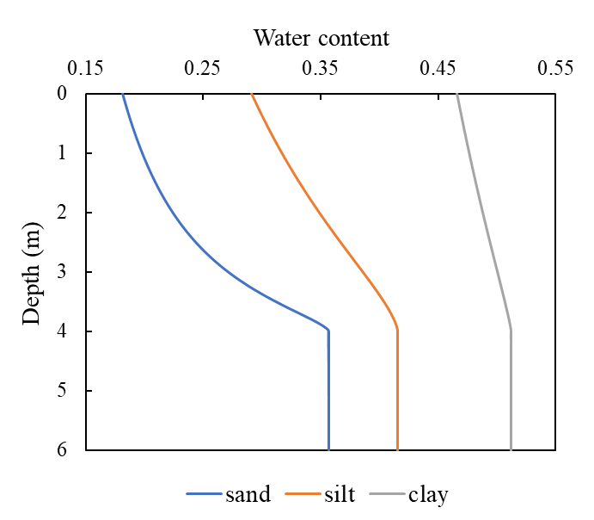
Figure 1. Stationary water content profiles of sand, silt, and clay
Given the positive correlation between conductivity and moisture content, as well as the negative correlation between the diffusion coefficient and moisture content, the distributions of conductivity and diffusion coefficient for the three soil types can be inferred from their respective moisture gradients. Sand, with its steeper moisture gradient and lower overall moisture retention, is expected to exhibit lower conductivity and higher diffusion coefficients, particularly in the unsaturated zone. Conversely, clay, with a more uniform moisture distribution and higher overall retention, is anticipated to show higher conductivity and significantly lower diffusion coefficients, with minimal variation across depths. Silt, with intermediate moisture retention and a moderate gradient, is likely to exhibit conductivity and diffusion coefficient values between those of sand and clay.

Task 4 Remote Inspection of Soil Properties and Pipe Corrosion

Soil box for GPR measurements
For the preliminary experiments, a rigid bulk container made of high-density polyethylene (HDPE) with approximate internal dimensions of 44 in. x 41 in. x 20 in. is used as the sand box (shown in Figure 2. The base of the box is modified with a 0.5 in. thick HDPE plate, and several symmetrically distributed 3/8 in. holes are drilled on it to allow water drainage. This drill bit size is determined with some preliminary experiments, as it allowed for moderate water drainage without losing the sand in the process. The side walls of the sand box are secured with waterproof tarp to retain moisture within the box, hence allowing maximum drainage only at the bottom of the box. The overall setup prevents water logging at the bottom of the soil during experimentation.
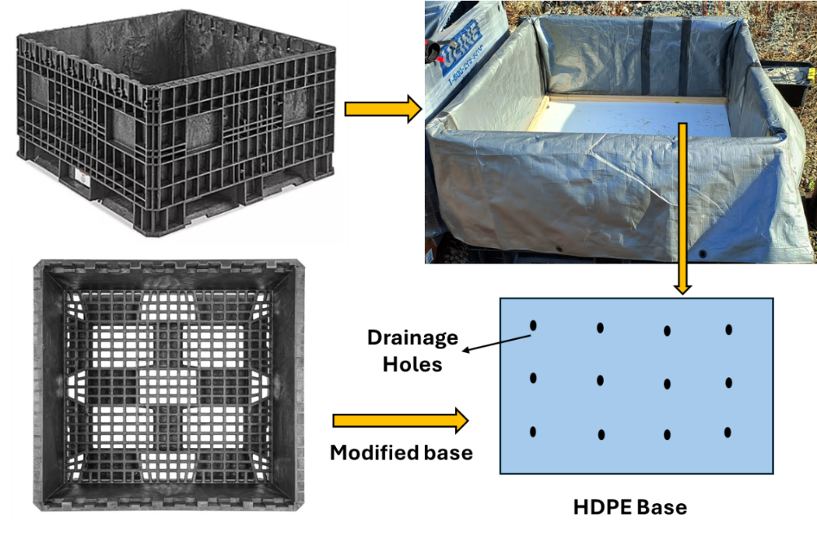
Figure 2 Soil box used for experimentation
Different types of reflectors (pipes and a plate) are placed at the bottom of the box as shown in Figure 3. Two pipes (internal diameters of 4 in. and 2 in.) with different types of protective coating (black colored Pritec wrap and green colored Scott tape) are used to simulate the pipelines field-like condition. To expand on the investigation, one fully corroded pipe (4 in. internal diameter) is also used in the process. The plate is used to optimize the experimental setup considering it acts as a relatively stable reflector in every GPR measurement. The plate results also validate the effect of changing the soil depth and moisture conditions. In this report, only the plate results are discussed.
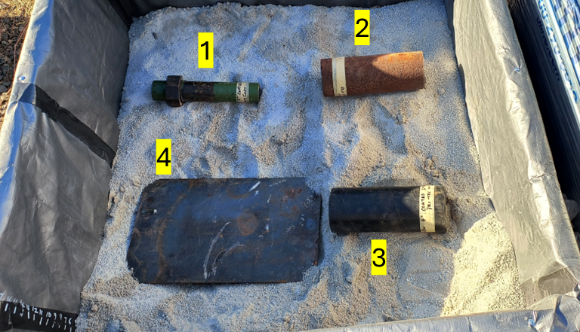
Figure 3 Buried pipes in the soil box (1: 2 in. diameter pipe, 2: 4 in. diameter rusted pipe, 3: 4 in. diameter coated pipe, 4: steel plate)
Sensor instrumentation
To monitor soil moisture at the depth of the plate, three capacitance-based low-cost moisture sensors (Spectrum WaterScout SMEC300 by Spectrum Technologies) are employed at different heights as per the schematic in Figure 4. SMEC300 sensor can measure volumetric moisture content, electrical conductivity of the soil, and the temperature simultaneously. The placement of these sensors facilitates the monitoring of moisture at different depths throughout the experiments. Furthermore, the experimental insights also allow for the improvement of the numerical model as it will be used to generate synthetic dataset over a wide range of soil and moisture combinations. Another sensor, which is a dielectric probe (Percometer) is used at a depth of pipeline allowing additional insights into the soil properties.
To ensure that the experimental setup mimics to that of real field test conditions, all-purpose sand is used to fill the box. This sand allows for reasonable drainage and avoid water logging conditions favorable for pipe corrosion. Furthermore, the box is filled with the sand in layers of 8-10 in. followed by sufficient compaction achieved by mechanical tamping. The sand was also moistened in the process to achieve better compaction.
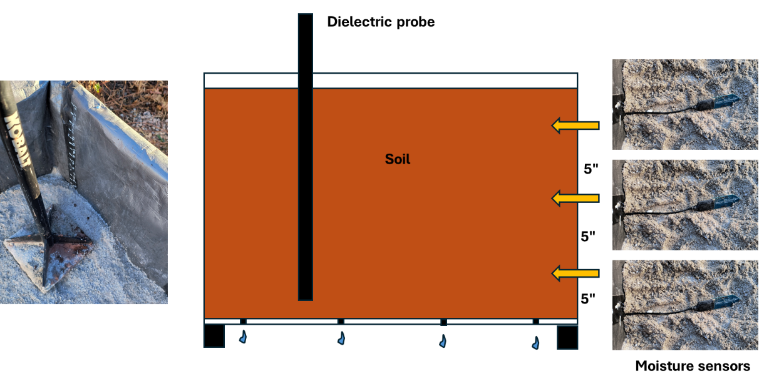
Figure 4 Schematic of sensor instrumentation

GPR measurements
During preliminary validation of the GPR results, the reflection from the plate is monitored with increasing soil depth. A 400 MHz antenna by GSSI is utilized for GPR measurements, and the signals are captured using the SIR-3000 data acquisition system. Considering the limited size of the sand box, the signal is capture in the time mode setting instead of desired distance mode. For a fixed position of the antenna over the plate, the data is recorded, and the reflection of the plate is determined. Figure 5 shows the results for the soil depth of 12 inches and 18 inches. It is evident that the reflection of the plate shifts to the deeper depths with the increasing soil depth. Hence it validates that second reflection peak is coming from the metal plate.
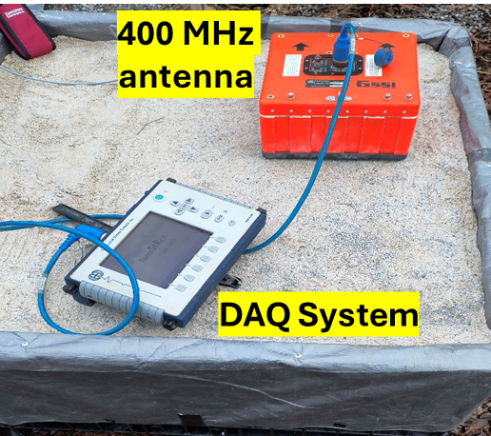
(a)
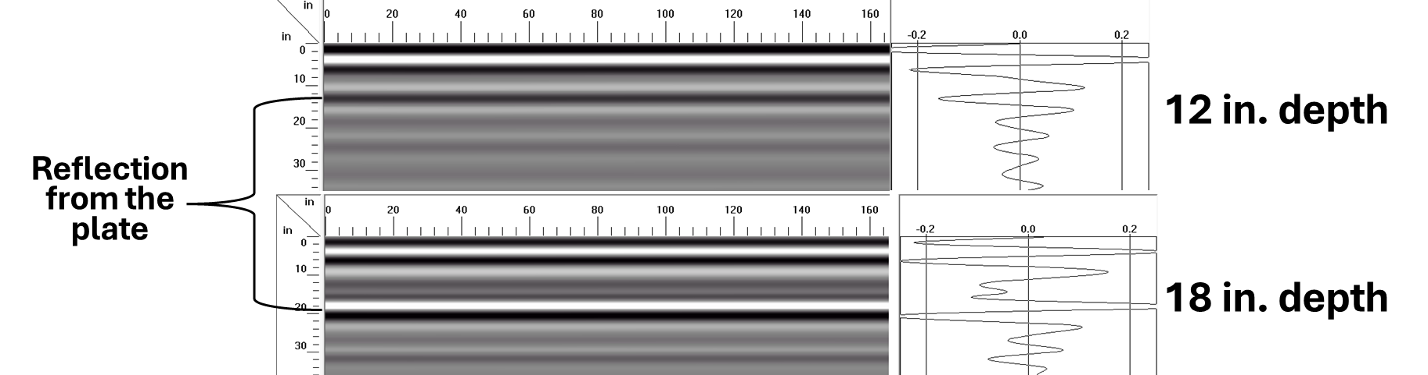
(b)
Figure 5(a) 400 MHz and data acquisition system for GPR measurements and (b) GPR measurements showing change in the plate reflection position with increasing sand depth
Once the desirable sand depth is achieved, sand was moistened further to achieve natural compaction after tamping. It is followed by periodic GPR measurements (subject to the cold weather conditions in New Jersey). At every measurement attempt, the soil moisture readings and dielectric probe readings are recorded. It is then followed by GPR measurements for fixed settings such as gain, dielectric constants, etc. For now, the GPR settings were kept constant to reduce the variables in the signal acquisitions, and solely focus on monitoring the effects of soil property change on the reflections from the plate. The experimental set up is left outdoors and the top of the box is covered with the waterproof tarp to eliminate the contribution from rain/ snow in the initial studies. When the weather will be suitable, the top cover will be removed to incorporate the effect of seasonal changes.
Figure 6 presents A-scans from GPR measurements under varying moisture conditions, respectively, for the raw and normalized data. The initial peaks comprise a combination of the direct wave and the ground wave, with the latter highlighted within a red envelope. These are followed by the reflection signals from the metal plate, which show different peak magnitudes as the soil moisture content changes. To facilitate comparison, the entire A-scan has been normalized to the peak positive amplitude of the reflected signal. A clear time delay in the arrival of the reflected peak from the plate is observed, corresponding to a delay of 0.25 ns as moisture increases from 18% to 30%. While this delay is prominent, a smaller but noticeable variation is also evident when the moisture changes to 26% compared to 30%.
Another observation is the relative amplitudes of the plate reflection and the ground wave. At 18% and 26% moisture, the ratio of the plate reflection amplitude to the ground wave amplitude is higher. However, as the moisture increases to 30%, this ratio decreases, indicating the influence of higher moisture levels on the attenuation and scattering of the reflected signal. These observations provide valuable insights into the effects of moisture on GPR signal propagation and reflection, highlighting the sensitivity of the technique to subtle changes in soil conditions.
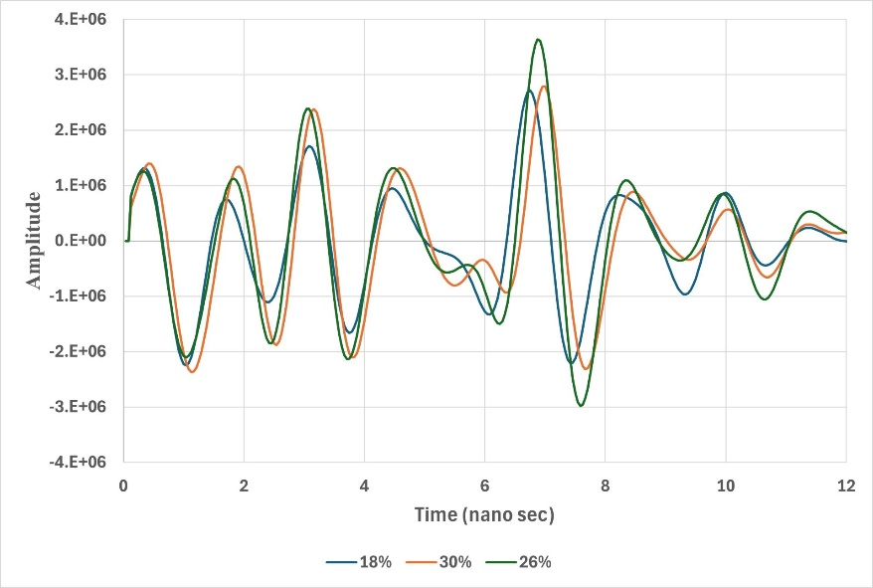
(a)
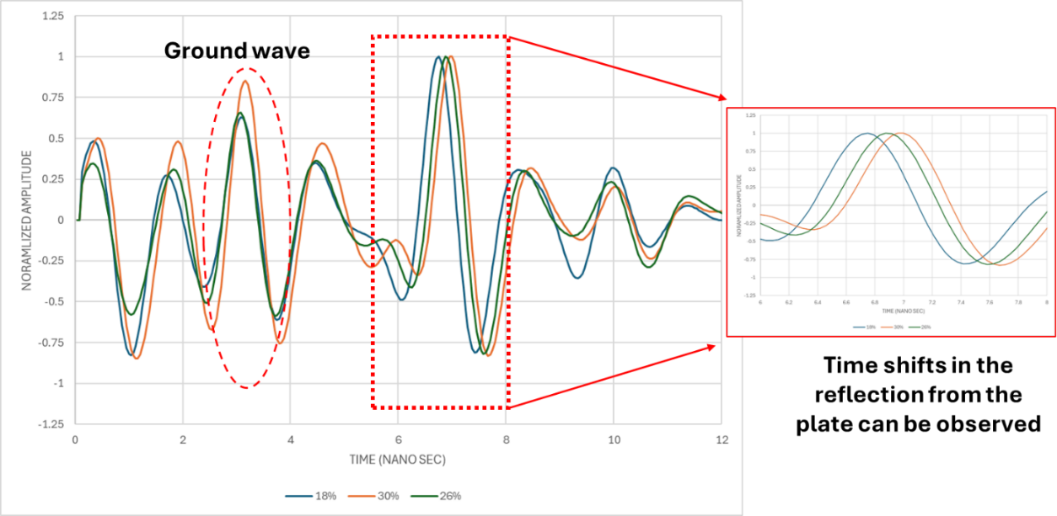
(b)
Figure 6 GPR measurements at different soil moisture contents: (a) raw signals and (b) normalized signals
Soil moisture measurements
The moisture profile data provides preliminary insights into how water is distributed across the top, middle, and bottom layers over time (Table 1). The top sensor indicates a steady decline in moisture, starting at 21.43% and dropping to 19.0% by the fifth measurement. Since the top section of the box is covered with a waterproof tarp, evaporation is not a significant factor. Instead, the decline in moisture at the top layer is likely due to gravitational movement of water downward, redistributing toward the lower layers. The middle sensor consistently records the lowest moisture levels, ranging between 11.8% and 13.6%. This relatively low moisture could be attributed to its position, which may not directly receive water from above and also loses moisture through both gravitational seepage and capillary action toward the top and bottom layers.
The bottom sensor shows significant fluctuations, with moisture increasing from 18.3% to a peak of 30.4% before stabilizing around 26.2%. This rise reflects water accumulation at the lower depths due to gravitational movement from the upper layers, although the presence of drainage in the bottom layer allows for slow and gradual release of water. The contrasting trends across the layers highlight the key processes at play: water redistribution from the top, minimal retention in the middle section, and controlled accumulation and drainage at the bottom.
Table 1 Moisture profile at different depths
Measurement | Top | Middle | Bottom
1 | 21.43 | 11.8 | 18.3
2 | 21 | 11.8 | 19.7
3 | 21.4 | 12.9 | 30.4
4 | 19.7 | 13.6 | 26.6
5 | 19 | 12.9 | 26.2

Electrical conductivity measurements
The electrical conductivity data is presented in Table 2 highlighting variation in soil characteristics across different layers. Electrical conductivity is influenced by factors such as soil moisture content, and soil texture, and it directly reflects the soil’s ability to support ionic flow.
The top layer shows relatively stable conductivity values of 0.89 mS, except for a drop to 0.74 mS in the third measurement and further to 0.37 mS by the fourth, before slightly recovering to 0.4 mS in the fifth measurement. These changes align with the declining moisture profile observed in the top sensor, as lower moisture content reduces the availability of conductive pathways for electrical currents. The middle layer shows minimal variation in conductivity, ranging between 0.14 and 0.20. This stability mirrors the consistently low moisture levels in this layer, suggesting that the middle soil remains relatively homogeneous, with limited changes in ionic concentration or saturation levels. The bottom layer exhibits more pronounced variation, with conductivity increasing significantly from 0.56 to 1.56 by the third measurement before decreasing to around 0.58–0.61 in subsequent measurements. This sharp peak corresponds to the observed rise in moisture content at the bottom sensor, indicating a temporary influx of ions and water that enhanced conductivity. The subsequent decrease likely reflects the drainage process, as water and dissolved ions gradually moved out of the layer. These observations highlight the dynamic interplay between moisture content and electrical conductivity. In particular, the high conductivity in the bottom layer during peak moisture levels captures the influence of water and dissolved ions in shaping the soil's electrical properties.
Table 2 Electrical conductivity (mS) at different depths
Measurement | Top | Middle | Bottom
1 | 0.89 | 0.17 | 0.56
2 | 0.89 | 0.17 | 0.57
3 | 0.74 | 0.15 | 1.56
4 | 0.37 | 0.20 | 0.58
5 | 0.4 | 0.14 | 0.61

Soil temperature measurement
In the first two measurements of Table 5, the temperature remains low across all layers, starting at 0°C and increasing slightly to 1°C. This stable, low-temperature condition may limit evaporation and soil water mobility, maintaining moisture distribution. By the third measurement, all layer’s reach 6°C, marking a noticeable rise that coincides with increased moisture levels in the bottom layer, potentially enhancing the soil's ionic mobility and contributing to the peak in electrical conductivity observed at this depth. The fourth measurement shows a further rise in temperature, with values of 9°C, 8°C, and 7°C for the top, middle, and bottom layers, respectively. This temperature gradient might slightly influence moisture redistribution as warmer temperatures promote water movement via evaporation or capillary action. However, by the fifth measurement, the temperature stabilizes at 6°C across all layers. These variations in temperature, though minor, highlight their role in modulating soil behavior, particularly in influencing moisture dynamics and electrical properties that are crucial for understanding GPR signal characteristics.
Table 5 Temperature profile at different depths using SMEC300 sensors
Measurement | Top | Middle | Bottom
1 | 0°C | 0°C | 1°C
2 | 1°C | 1°C | 1°C
3 | 6°C | 6°C | 6°C
4 | 9°C | 8°C | 7°C
5 | 6°C | 6°C | 6°C

Dielectric probe measurements
The dielectric probe data provides valuable insights into the ability of soil layers to store and dissipate electrical energy by measuring the real and imaginary dielectric constant, as shown in Table 6. The real and imaginary parts of the dielectric constant are directly influenced by the moisture levels and ionic activity, which are modulated by temperature changes.
Initiating with the value of 11.66 and 11.59 in the first two days, the real dielectric constant (indicative of water content) is higher during the third measurement (13.23), aligning with the peak moisture level recorded by the bottom moisture sensor (30.4%). On contrary, a significant drop in the imaginary part of the dielectric constant (from 51.74 to 18.92) during this period suggests a reduction in energy losses, possibly due to water redistribution and the stabilization of ionic movement as the soil temperature increases. This trend continues in subsequent measurements as moisture stabilizes, reflecting in relatively steady dielectric readings.
Comparing the temperature readings from the dielectric probe and the moisture sensor at the bottom layer reveals close alignment. For example, during the first and second measurements, the dielectric probe records 1.4°C and 0.7°C, similar to the moisture sensor's readings of 1°C and 1°C, respectively. In the third measurement, both devices show comparable increases (6.1°C for the dielectric probe and 6°C for the moisture sensor), indicating consistency in temperature monitoring. These parallels suggest that the dielectric probe accurately reflects the thermal environment within the soil, further validating its correlation with moisture-driven variations in electromagnetic properties.
Table 6 Dielectric probe measurements
Measurement | Re. (DC) | Im. (DC) | Temperature (°C)
1 | 11.66 | 51.74 | 1.4
2 | 11.59 | 50.02 | 0.7
3 | 13.23 | 18.92 | 6.1
4 | 12.44 | 26.73 | 7.4
5 | 11.97 | 18.61 | 6.3

